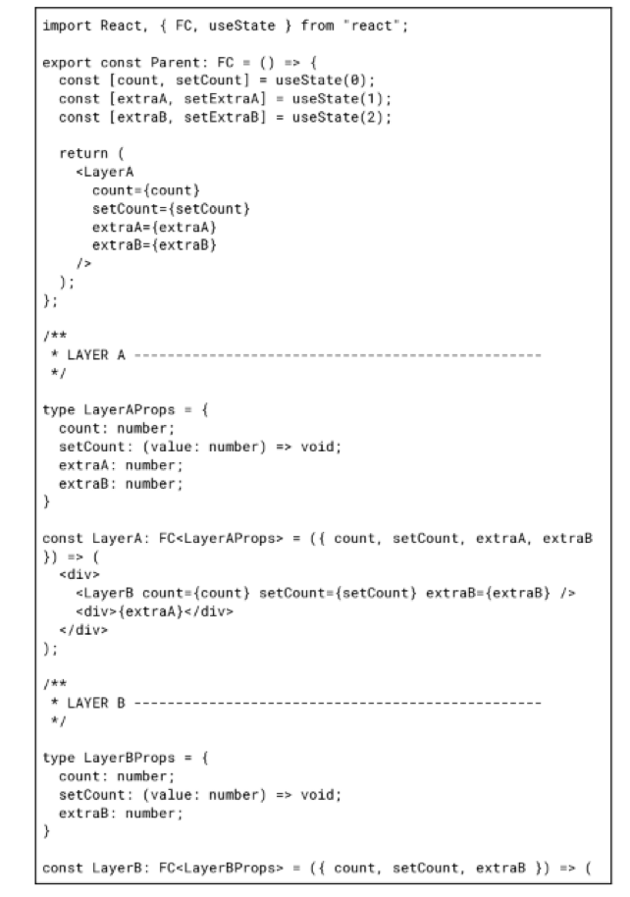

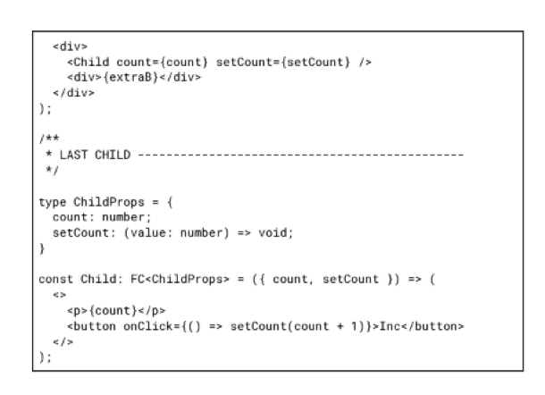

Review following code snippet and answer questions:

1. What’s wrong with this code snippet?
2. How can we improve it?
3. What benefits and drawbacks of each method?

1. In this example, states are created in the Parent component, which are passed as props to child components at several levels of nesting. This practice is called Props Drilling, which is an anti-pattern.

Throwing props in child components in order to pass them to other child components leads to code clutter, unnecessary re-renders, and difficulties with extending this code.

2. In this example, we see excessive nesting of child components We can send useless state declarations from parent to child components. Also, we can restructure our React app and create Parent children at the same nesting level. If we need to keep nesting we can use Contex or Redux.

3. Disadvantages of Props Drilling: making it harder to understand how props work. Unnecessary render on state change, components that don't use forward prop.